IA At-A-Glance

IB Mathematics: Applications and Interpretation IA

Mathematical Exploration

Key Sources for Writing in Mathematics
Phrasebook PDF: Stephen Howe, Kristina Henriksson - PhraseBook for Writing Papers and Research in English-CreateSpace Independent Publishing Platform (2007).pdf

Manchester Academic PhraseBank

Rules and Tips for Writing in Mathematics

IA Criteria
Criterion A 4 Presentation
Criterion B 4 Mathematical communication
Criterion C 3 Personal engagement
Criterion D 3 Reflection
Criterion E 6 Use of mathematics
Approximately 12-20 pages, double-spaced and 1” margins

Overview of Written Mathematical Exploration

Mathematics Applications and Interpretations SL&HL:
Mathematical Exploration

Title of your exploration

Page Count
Table of contents

Introduction

Personal interest and intentions/purpose for mathematically exploring your topic.
Preliminary research conducted to find out how others have approached similar or related problems mathematically. Explain how these models or approaches will (or will not) inform your own.

Aim and Overview of Exploration

Research Question and overview of sections in sequence.

Assumptions

What do you need to assume or exclude about the real world scenario/context in order to treat the problem mathematically and to limit complexity for the scope of this project?
Body Sections A-n

Explain method and mathematical functions, formulae, models, statistical methods, probability calculations, software or technology; define variables in terms of real-world context and data

Test method by performing calculations and presenting resulting data
mathematical representation(s): graphs, tables, diagrams, calculations

Analyze Results in Writing
describe graphs, tables, diagrams, calculations
Identify trends or patterns

Engage Results and Reflect on Process
Are the results satisfactory or do you need to fine tune your method and test it again?
Can you develop and test an additional method to produce data that supplement or verify these results?

…Transition to next section.
🔁 Include a section for each method or model explored over the course of your exploration.
Discussion and Conclusion

Engage combined results and Reflect on overall process:

Summarize findings as an answer to the aim of your exploration,

Compare findings to your prior expectations and any other models and approaches referenced in the introduction,

Plug back into Real-World Context,

Evaluate validity, limitations, omissions/ assumptions with respect to real-world context,

Reflect on what you learned or discovered in the exploration process,

Identify next steps for applying your findings or suggest further/alternative research.
Bibliography

Include full MLA citations for any and all:
Sources of data,
Sources for images,
Sources of background info,
Previous studies you reference,
Math reference sources used

Citation generator and guide linked here!

Appendices

Tables of raw data

Survey(s)

Supporting documentation

Candidate declaration

I confirm that this work is my own work and is the final version. I have acknowledged each use of the words or ideas of another person, whether written, oral or visual.

Candidate’s signature: .................................................
Date: .............................

Introduction (.5-1 page)

Introduction (.5 - 1 page)
Personal interest and intentions for mathematically exploring topic

Personal interest (Hook/Wind-up): Opening sentences identify the topic and set the scene where your interest in the topic sparks.

Intentions for mathematical exploration (Pitch): Connect this experience of initial interest with your present intentions for exploring the topic using mathematics→something you want to do, make, or know outside of math class

- Curious about how to optimize something, or the “best” way to achieve something within specific parameters
- Applying math to a personal project or goal
- Applying math to understanding or building on another IB course
- Applying math to a situation in which you could offer strategies or advise on a course of action
- Applying math to real world issues in industry, policy, education, marketing, etc…

Example Phrasing:
My interest stems from a personal experience I had…
…This led me to question, [statement of research question]

Driven by my passion for…/ I wanted to…
…I decided to explore it from a mathematical perspective and find…

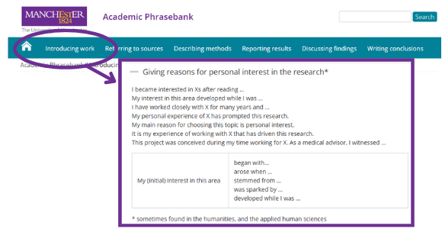
→ In your introductory paragraph, you are:
- Posing a real-world problem of personal interest, which establishes the context and motivation for the exploration
- leading into your stated research question that mathematically represents the situation,
  - Include any preliminary research, others’ models or approaches, or mathematical concepts and principles that helped you figure out how to represent the real-world problem mathematically.
- and introducing your mathematical exploration as your plan to answer that question (“Aim”).

Aim and Overview of Exploration (.5-1 page)

Aim (.5 - 1 page)
This is where you demonstrate your understanding of the course mathematics you will apply in your solution method and how they build toward an answer or solution to your question.

Example phrasing:
- My exploration seeks to / aims to / addresses / investigates…
- The purpose / focus of my exploration, therefore, is to…
- My objective is to…
- I designed my mathematical exploration to test the hypothesis that…

Overview of Exploration (Solution Methods/Process)
What you’re doing…
Outlining the sequence of mathematical steps you take to construct an answer to your question. Using the mathematical and technical terms learned in class:
- Identify how the data will be collected, sampled, sourced and why (=give your brief reasoning why the collected data is appropriate)
- State the mathematical processes and tools you will use and why (=give your brief reasoning why the math and tech are appropriate).
- Clearly link each step in sequence to establish the development or advancement toward finding an overall answer or solution.

Ways to say it…
- To answer this question, I will use / need to find / develop___. I will then further develop my exploration by___.
- First, I will use _____ to ______. I will then _____ in order to ____.
- I will then use ____ to establish if ____.
- Then, I will investigate ____ to see if ____.
- Next I will ____ to determine _____.
- Finally, ____ .

Assumptions

What do you need to assume or exclude about the real world scenario/context in order to treat the problem mathematically and to limit complexity for the scope of this project?

  - For the purposes of my exploration, I will need to make some crucial assumptions: …

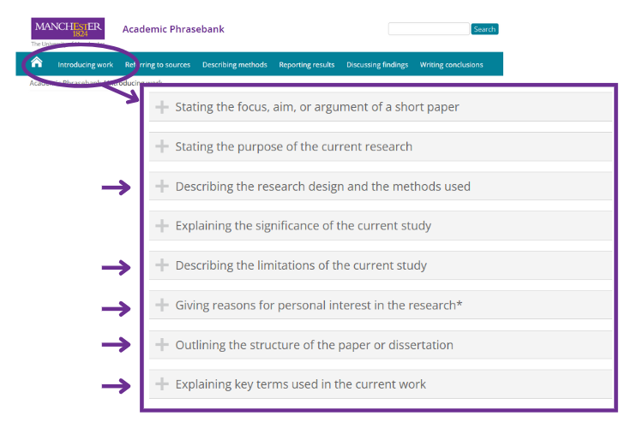

Body Section: Method I

Body Section: Method I

For each body section, include the following subsections:
Method
↓
Results
↓
Discuss Findings → next section

Method
(Method + Reasoning)

Methods  by examining … … is or can be obtained by … with the help of … with the aid of …  by means of … by application of … A useful tool for … is … an indispensable tool in …  this device enables us to …  we have a number of techniques at our disposal  …, drawing on …  incorporating a number of … in the context of … in conjunction with … based primarily on …  a process involving … within the framework of …  a or the frame of reference  First we select … ; we then select …  Stage or step 1 involves …. In stage or step 2, we … Phase 1 …; phase 2 …; phase 3 …  We used …  … to study the effects of … on … … to examine the effects of … on …  … to model the effects of … on … … to estimate the effects of … on …  To determine whether …, we … To assess whether …, we …  To measure the effects of … on …, we … To assess whether … was affected by …, we …  To investigate whether …, we analyzed …  … was or were measured by … … was determined for each … by …  … was measured before and after … … was used to measure … … was equipped with …  … was transferred to … … was or is used in the analysis of … to determine …  … provides a useful estimate of or for … the simulation showed that … in the presence of …  in the absence of … after addition of … substitution of … for …  measurements were made or taken at … sites  For this we can use a number of strategies One option here would be to …  Adjustment of … allows us to … … is enhanced if we …  This method can be used to obtain … This technology enables us to …  The most usual method is …  … is commonly used in … to measure etc. … … by the … method  … according to the … method  The method etc. can also be adapted or extended to …  Using this method or technique, we are or were able to … | The “personal engagement” criterion (3 marks) assesses the extent to which the student engages with the topic by exploring the mathematics and making it their own. It is not a measure of effort.  Personal engagement may be recognized in different ways. These include thinking independently or creatively, presenting mathematical ideas in their own way, exploring the topic from different perspectives, making and testing predictions.  Outstanding: The student demonstrates authentic personal engagement in the exploration in numerous instances and they are of a high quality. It is evident that these drive the exploration forward in a creative way. It leaves the impression that the student has developed, through their approach, a complete understanding of the context of the exploration topic and the reader better understands the writer’s intentions.
Reasoning  to verify … to establish … to facilitate … to capture … to measure accurately …  the reason for this is … Because of this, … it should be stressed that …  we might expect that … it is convenient to … it is helpful to consider …  It is helpful here to … In practice, … the application of … to …  Particular attention will be paid to … to examine more closely  … will be or was investigated further by … … will be examined in greater detail  Based on …, we decided to … This has been shown to … In doing so, …  it will be useful to examine … … deserves special attention we opted to …  from this perspective This approach is based on … … is frequently used to …  The experiment was designed to … The advantage of this approach is that …  This approach has the advantage of or that … This approach has a number of advantages: firstly, …  … gives a better basis for … it combines … with or and …  This format allows us to see more clearly how … In this way, we are or were able to target …  This enables one to create …  In this way, we are able to eliminate several of the problems of previous approaches or methods  One difficulty in … is … A or one significant problem is …  Coordination of … and … is essential or particularly difficult a compromise  One strategy would be to … … avoids this difficulty by …  the practical problems involved in … an alternative way of approaching the problem  Another way of looking at the question of … | The “Use of mathematics” criterion (6 marks) assesses to what extent students use mathematics that is relevant to the exploration.  - Demonstrate knowledge and understanding  - Apply mathematics in different contexts  - Apply problem-solving techniques  - Recognize and explain patterns, where appropriate  - Generalize and justify conclusions  Relevant refers to mathematics that supports the development of the exploration towards the completion of its aim. Overly complicated mathematics where simple mathematics would suffice is not relevant.  Students are expected to produce work that is commensurate with the level of the course, which means it should not be completely based on mathematics listed in the prior learning. The mathematics explored should either be part of the syllabus, or at a similar level.  A key word in the descriptor is demonstrated. The command term demonstrate means “to make clear by reasoning or evidence, illustrating with examples or practical application.”
Mathematical Functions and Formulae, Models, Statistical method, Probability calculations  Write all mathematical expressions using the Insert > Equation function in your Word or google doc.  Define all variables with the value and units they represent.  To determine ______, the following formula is used:  $Y=x^{2}+v$  where Y is ____ in [units], x is _____ in [units], and v is ____ in [units].  We can calculate _______ with the function  $f(x)=x^{2}+v$  where x is _____ in [units], and v is ____ in [units].  Defining variables, numerical values, and specific terminology  the types of … in terms of …  with reference to …  this formula allows us to …  We defined … as …  By … we mean … By … is meant …  … is defined as … … can be defined as … … is or are often defined as …  … are defined in this study as follows:  … can be characterized as … … can be formulated as follows:  … denotes … … represents … is representative of …  …, which is or are represented here by or as … … can be written as …  … can be expressed more simply as …  … is or was determined as follows: … is or was measured by …  … is or was calculated as follows: … is or was calculated by …  where … is the … represents denotes  Data Sources and Collection  primary sources were: secondary sources included … an extensive database  to collect data on …  We obtained data on … from … Data on … were collected … … by …  … between … and … … during … … at regular intervals …  … continuously  The data were or are compiled from a number of or several sources  Continuous measurements of … were made …  Sampling of … was carried out over a two-week etc. period in ___.  Conditions during the sampling period were …  a random sample of … … selected or chosen at random from …  … randomly selected from … … provides a representative sample of …  It is estimated that there are …  No data were available for or on … | The “mathematical communication” criterion (4 marks) assesses to what extent the student has:  - used appropriate mathematical language (notation, symbols, terminology). Calculator and computer notation is acceptable only if it is software generated. Otherwise it is expected that students use appropriate mathematical notation in their work  - defined key terms and variables, where required  - used multiple forms of mathematical representation, such as formulae, diagrams, tables, charts, graphs and models, where appropriate  - used a deductive method and set out proofs logically where appropriate  Examples of level 1 can include graphs not being labelled, consistent use of computer notation with no other forms of correct mathematical communication.  Level 4 can be achieved by using only one form of mathematical representation as long as this is appropriate to the topic being explored. For level 4, any minor errors that do not impair clear communication should not be penalized.

Results
(Mathematical representation and written interpretation)
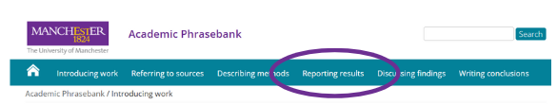

Visual representation  Title each table, graph, diagram, etc., sequentially with Figure #. Wherever you refer to it in the text, indicate the figure number like this: (Fig. #). Identify specialized software or technological tools when used to produce the representation.  Tables: Label each column and/or row with units, and corresponding variable if relevant; draw attention to significant values or patterns with color or graphics if relevant  Example:  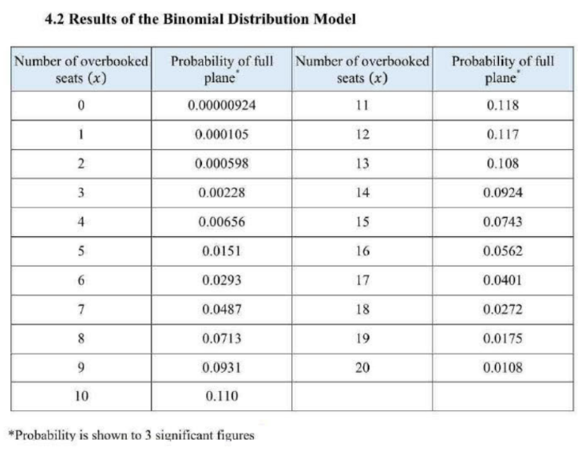  Graphs and Charts: Label axes with units and corresponding variable, label significant points with variables/letters and define them in the text, annotate significant areas of your graph with color and graphics to graphs if relevant  Examples:  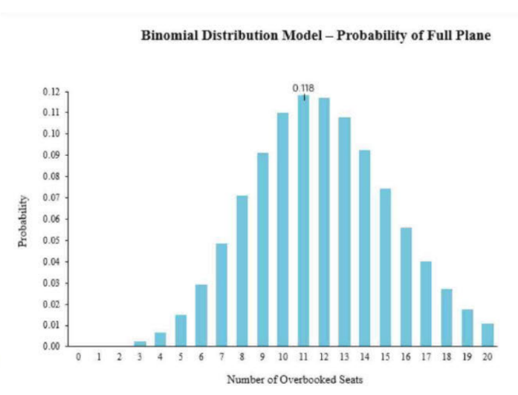  _______________________________________________  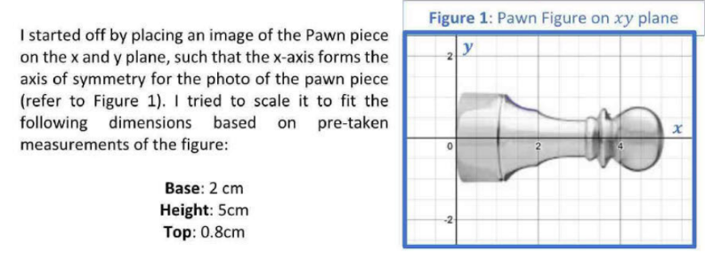  _______________________________________________  Diagrams: Label each significant component, use color, image, lines, and arrows to visually represent relationships between the labeled components.  You’ll want to generate your own tables, graphs, and diagrams, but if you need to include data or images from another source(s), include the citation in a title, e.g., Figure 2: Demographic Data for 2023 (Census.gov), AND include the full bibliographic reference in your works cited. | The “mathematical communication” criterion (4 marks) assesses to what extent the student has:  - used appropriate mathematical language (notation, symbols, terminology). Calculator and computer notation is acceptable only if it is software generated. Otherwise it is expected that students use appropriate mathematical notation in their work  - defined key terms and variables, where required  - used multiple forms of mathematical representation, such as formulae, diagrams, tables, charts, graphs and models, where appropriate  - used a deductive method and set out proofs logically where appropriate  Examples of level 1 can include graphs not being labelled, consistent use of computer notation with no other forms of correct mathematical communication.  Level 4 can be achieved by using only one form of mathematical representation as long as this is appropriate to the topic being explored. For level 4, any minor errors that do not impair clear communication should not be penalized.  The “Use of mathematics” criterion (6 marks) assesses to what extent students use mathematics that is relevant to the exploration.  - Demonstrate knowledge and understanding  - Apply mathematics in different contexts  - Apply problem-solving techniques  - Recognize and explain patterns, where appropriate  - Generalize and justify conclusions  Relevant refers to mathematics that supports the development of the exploration towards the completion of its aim. Overly complicated mathematics where simple mathematics would suffice is not relevant.  A key word in the descriptor is demonstrated. The command term demonstrate means “to make clear by reasoning or evidence, illustrating with examples or practical application.”
Written interpretation
For each mathematical representation of your resulting data (table, graph, diagram, etc.), thoroughly identify and interpret the represented results in writing.

Figures, tables and graphs
table X shows … figure X illustrates … as seen in figure X
as shown in the table above or below
examples of … are shown in figure or table X The image shows that …
The figures, data etc. … … are given above … are presented below
… are shown in table X … are listed above or below
… are summarized in figure or table X … are illustrated in figure X
… are illustrated in the figure, graph or table above or below
… are shown in the graph above or below
… are shown in brackets or parentheses
… are given in the appendix Figure X shows …
… the size of … … the level of … … the extent of …
… the effect of … … the rate of … … the concentration of …
… the distribution of … All values are given as …
each column represents … The shaded area represents …
… based on the data given in table X
Values in brackets or parentheses are …
An alternative way of presenting … is to …

More phrases for interpreting results
We can see in the table / graph / diagram above that…
This table / graph / diagram of the data suggests / hints / implies / shows…
The proportion of … ranged from … to … ranging from … to …
… ranked in order of … … is proportional to …
… was significantly higher in … than in … … was significantly lower in …
… peaked at … … was higher than expected
… was lower than expected the expected number of …

Discuss Findings
(Analysis and Reflection)
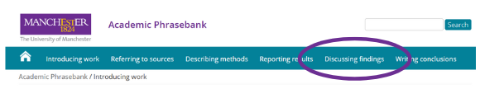
Analysis  Use these phrases in the body sections to analyze the results of mathematical processes, calculations, and representations.  to examine … to examine … more closely to observe … to observe … in detail  to evaluate … to assess … to assess the significance of …  In determining …, … to determine whether/whether or not …  We observed … By analyzing …,  … was analyzed by or for … The analysis here is based on …  It is relatively easy to describe … one immediately obvious feature of … is …  A quick glance at … shows that …  … exhibit classic signs or symptoms of … From … it is apparent that …  … is immediately apparent … is most pronounced in …  … shows evidence of …  Superficially at least, … Underlying … is the view etc. that …  Analysis of the data revealed … Closer examination of … reveals that …  Closer inspection revealed that … Viewed in this way, …  There is some indication that … Observations of … suggest that …  The presence of … can be tested by …  An important test for … is whether or not …  … may be or is confirmed by … … tends to occur or be found in …  exposure to … results in … One way of examining or viewing … | The “reflection” criterion (3 marks) assesses how the student reviews, analyses and evaluates the exploration. Although reflection may be seen in the conclusion to the exploration, it may also be found throughout the exploration.  Critical reflection is reflection that is crucial, deciding or deeply insightful. It will often develop the exploration by addressing the mathematical results and their impact on the student’s understanding of the topic. Some ways of showing critical reflection are: considering what next, discussing implications of results, discussing strengths and weaknesses of approaches, and considering different perspectives.  Substantial evidence means that the critical reflection is present throughout the exploration. If it appears at the end of the exploration it must be of high quality and demonstrate how it developed the exploration in order to achieve a level 3.
Discussing Findings and Reflecting
(and transitioning to next section)
Also use “discussion” phrases to further demonstrate critical reflection and personal engagement by identifying limitations, relating results to the aim and real-world context, and deciding on next steps / what you still need to know.
The importance of … is demonstrated by the fact that …
… assumes a special significance because or as …
One of the most obvious consequences of … is the/an important observation that …
A point that can be made is that …
This may be discussed in terms of … … is perhaps best viewed as …
If this is the case, then … This attests to … This agrees with …
… is or are, in effect, … … supports the notion that …
… may be inferred from …
This would suggest that … There is some evidence to suggest that
The question arises whether … It is an open question whether …
This raises a further question: This raises the issue whether …
This raises a number of questions.

Body Section: Method II...

Body Section: Method II…
Method
↓
Results
↓
Discuss Findings → next section

Method
(Method + Reasoning)
Methods  by examining … … is or can be obtained by … with the help of … with the aid of …  by means of … by application of … A useful tool for … is … an indispensable tool in …  this device enables us to …  we have a number of techniques at our disposal  …, drawing on …  incorporating a number of … in the context of … in conjunction with … based primarily on …  a process involving … within the framework of …  a or the frame of reference  First we select … ; we then select …  Stage or step 1 involves …. In stage or step 2, we … Phase 1 …; phase 2 …; phase 3 …  We used …  … to study the effects of … on … … to examine the effects of … on …  … to model the effects of … on … … to estimate the effects of … on …  To determine whether …, we … To assess whether …, we …  To measure the effects of … on …, we … To assess whether … was affected by …, we …  To investigate whether …, we analyzed …  … was or were measured by … … was determined for each … by …  … was measured before and after … … was used to measure … … was equipped with …  … was transferred to … … was or is used in the analysis of … to determine …  … provides a useful estimate of or for … the simulation showed that … in the presence of …  in the absence of … after addition of … substitution of … for …  measurements were made or taken at … sites  For this we can use a number of strategies One option here would be to …  Adjustment of … allows us to … … is enhanced if we …  This method can be used to obtain … This technology enables us to …  The most usual method is …  … is commonly used in … to measure etc. … … by the … method  … according to the … method  The method etc. can also be adapted or extended to …  Using this method or technique, we are or were able to … | The “personal engagement” criterion (3 marks) assesses the extent to which the student engages with the topic by exploring the mathematics and making it their own. It is not a measure of effort.  Personal engagement may be recognized in different ways. These include thinking independently or creatively, presenting mathematical ideas in their own way, exploring the topic from different perspectives, making and testing predictions.  Outstanding: The student demonstrates authentic personal engagement in the exploration in numerous instances and they are of a high quality. It is evident that these drive the exploration forward in a creative way. It leaves the impression that the student has developed, through their approach, a complete understanding of the context of the exploration topic and the reader better understands the writer’s intentions.
Reasoning  to verify … to establish … to facilitate … to capture … to measure accurately …  the reason for this is … Because of this, … it should be stressed that …  we might expect that … it is convenient to … it is helpful to consider …  It is helpful here to … In practice, … the application of … to …  Particular attention will be paid to … to examine more closely  … will be or was investigated further by … … will be examined in greater detail  Based on …, we decided to … This has been shown to … In doing so, …  it will be useful to examine … … deserves special attention we opted to …  from this perspective This approach is based on … … is frequently used to …  The experiment was designed to … The advantage of this approach is that …  This approach has the advantage of or that … This approach has a number of advantages: firstly, …  … gives a better basis for … it combines … with or and …  This format allows us to see more clearly how … In this way, we are or were able to target …  This enables one to create …  In this way, we are able to eliminate several of the problems of previous approaches or methods  One difficulty in … is … A or one significant problem is …  Coordination of … and … is essential or particularly difficult a compromise  One strategy would be to … … avoids this difficulty by …  the practical problems involved in … an alternative way of approaching the problem  Another way of looking at the question of … | The “Use of mathematics” criterion (6 marks) assesses to what extent students use mathematics that is relevant to the exploration.  - Demonstrate knowledge and understanding  - Apply mathematics in different contexts  - Apply problem-solving techniques  - Recognize and explain patterns, where appropriate  - Generalize and justify conclusions  Relevant refers to mathematics that supports the development of the exploration towards the completion of its aim. Overly complicated mathematics where simple mathematics would suffice is not relevant.  Students are expected to produce work that is commensurate with the level of the course, which means it should not be completely based on mathematics listed in the prior learning. The mathematics explored should either be part of the syllabus, or at a similar level.  A key word in the descriptor is demonstrated. The command term demonstrate means “to make clear by reasoning or evidence, illustrating with examples or practical application.”
Mathematical Functions and Formulae, Models, Statistical method, Probability calculations  Write all mathematical expressions using the Insert > Equation function in your Word or google doc.  Define all variables with the value and units they represent.  To determine ______, the following formula is used:  $Y=x^{2}+v$  where Y is ____ in [units], x is _____ in [units], and v is ____ in [units].  We can calculate _______ with the function  $f(x)=x^{2}+v$  where x is _____ in [units], and v is ____ in [units].  Defining variables, numerical values, and specific terminology  the types of … in terms of …  with reference to …  this formula allows us to …  We defined … as …  By … we mean … By … is meant …  … is defined as … … can be defined as … … is or are often defined as …  … are defined in this study as follows:  … can be characterized as … … can be formulated as follows:  … denotes … … represents … is representative of …  …, which is or are represented here by or as … … can be written as …  … can be expressed more simply as …  … is or was determined as follows: … is or was measured by …  … is or was calculated as follows: … is or was calculated by …  where … is the … represents denotes  Data Sources and Collection  primary sources were: secondary sources included … an extensive database  to collect data on …  We obtained data on … from … Data on … were collected … … by …  … between … and … … during … … at regular intervals …  … continuously  The data were or are compiled from a number of or several sources  Continuous measurements of … were made …  Sampling of … was carried out over a two-week etc. period in ___.  Conditions during the sampling period were …  a random sample of … … selected or chosen at random from …  … randomly selected from … … provides a representative sample of …  It is estimated that there are …  No data were available for or on … | The “mathematical communication” criterion (4 marks) assesses to what extent the student has:  - used appropriate mathematical language (notation, symbols, terminology). Calculator and computer notation is acceptable only if it is software generated. Otherwise it is expected that students use appropriate mathematical notation in their work  - defined key terms and variables, where required  - used multiple forms of mathematical representation, such as formulae, diagrams, tables, charts, graphs and models, where appropriate  - used a deductive method and set out proofs logically where appropriate  Examples of level 1 can include graphs not being labelled, consistent use of computer notation with no other forms of correct mathematical communication.  Level 4 can be achieved by using only one form of mathematical representation as long as this is appropriate to the topic being explored. For level 4, any minor errors that do not impair clear communication should not be penalized.

Results
(Mathematical representation and written interpretation)

Visual representation  Title each table, graph, diagram, etc., sequentially with Figure #. Wherever you refer to it in the text, indicate the figure number like this: (Fig. #). Identify specialized software or technological tools when used to produce the representation.  Tables: Label each column and/or row with units, and corresponding variable if relevant; draw attention to significant values or patterns with color or graphics if relevant  Example:  Graphs and Charts: Label axes with units and corresponding variable, label significant points with variables/letters and define them in the text, annotate significant areas of your graph with color and graphics to graphs if relevant  Examples:  Diagrams: Label each significant component, use color, image, lines, and arrows to visually represent relationships between the labeled components.  You’ll want to generate your own tables, graphs, and diagrams, but if you need to include data or images from another source(s), include the citation in a title, e.g., Figure 2: Demographic Data for 2023 (Census.gov), AND include the full bibliographic reference in your works cited. | The “mathematical communication” criterion (4 marks) assesses to what extent the student has:  - used appropriate mathematical language (notation, symbols, terminology). Calculator and computer notation is acceptable only if it is software generated. Otherwise it is expected that students use appropriate mathematical notation in their work  - defined key terms and variables, where required  - used multiple forms of mathematical representation, such as formulae, diagrams, tables, charts, graphs and models, where appropriate  - used a deductive method and set out proofs logically where appropriate  Examples of level 1 can include graphs not being labelled, consistent use of computer notation with no other forms of correct mathematical communication.  Level 4 can be achieved by using only one form of mathematical representation as long as this is appropriate to the topic being explored. For level 4, any minor errors that do not impair clear communication should not be penalized.  The “Use of mathematics” criterion (6 marks) assesses to what extent students use mathematics that is relevant to the exploration.  - Demonstrate knowledge and understanding  - Apply mathematics in different contexts  - Apply problem-solving techniques  - Recognize and explain patterns, where appropriate  - Generalize and justify conclusions  Relevant refers to mathematics that supports the development of the exploration towards the completion of its aim. Overly complicated mathematics where simple mathematics would suffice is not relevant.  A key word in the descriptor is demonstrated. The command term demonstrate means “to make clear by reasoning or evidence, illustrating with examples or practical application.”
Written interpretation
For each mathematical representation of your resulting data (table, graph, diagram, etc.), thoroughly identify and interpret the represented results in writing.

Figures, tables and graphs
table X shows … figure X illustrates … as seen in figure X
as shown in the table above or below
examples of … are shown in figure or table X The image shows that …
The figures, data etc. … … are given above … are presented below
… are shown in table X … are listed above or below
… are summarized in figure or table X … are illustrated in figure X
… are illustrated in the figure, graph or table above or below
… are shown in the graph above or below
… are shown in brackets or parentheses
… are given in the appendix Figure X shows …
… the size of … … the level of … … the extent of …
… the effect of … … the rate of … … the concentration of …
… the distribution of … All values are given as …
each column represents … The shaded area represents …
… based on the data given in table X
Values in brackets or parentheses are …
An alternative way of presenting … is to …

More phrases for interpreting results
We can see in the table / graph / diagram above that…
This table / graph / diagram of the data suggests / hints / implies / shows…
The proportion of … ranged from … to … ranging from … to …
… ranked in order of … … is proportional to …
… was significantly higher in … than in … … was significantly lower in …
… peaked at … … was higher than expected
… was lower than expected the expected number of …

Discuss Findings
(Analysis and Reflection)
Analysis  Use these phrases in the body sections to analyze the results of mathematical processes, calculations, and representations.  to examine … to examine … more closely to observe … to observe … in detail  to evaluate … to assess … to assess the significance of …  In determining …, … to determine whether/whether or not …  We observed … By analyzing …,  … was analyzed by or for … The analysis here is based on …  It is relatively easy to describe … one immediately obvious feature of … is …  A quick glance at … shows that …  … exhibit classic signs or symptoms of … From … it is apparent that …  … is immediately apparent … is most pronounced in …  … shows evidence of …  Superficially at least, … Underlying … is the view etc. that …  Analysis of the data revealed … Closer examination of … reveals that …  Closer inspection revealed that … Viewed in this way, …  There is some indication that … Observations of … suggest that …  The presence of … can be tested by …  An important test for … is whether or not …  … may be or is confirmed by … … tends to occur or be found in …  exposure to … results in … One way of examining or viewing … | The “reflection” criterion (3 marks) assesses how the student reviews, analyses and evaluates the exploration. Although reflection may be seen in the conclusion to the exploration, it may also be found throughout the exploration.  Critical reflection is reflection that is crucial, deciding or deeply insightful. It will often develop the exploration by addressing the mathematical results and their impact on the student’s understanding of the topic. Some ways of showing critical reflection are: considering what next, discussing implications of results, discussing strengths and weaknesses of approaches, and considering different perspectives.  Substantial evidence means that the critical reflection is present throughout the exploration. If it appears at the end of the exploration it must be of high quality and demonstrate how it developed the exploration in order to achieve a level 3.
Discussing Findings and Reflecting
(and transitioning to next section)
Also use “discussion” phrases to further demonstrate critical reflection and personal engagement by identifying limitations, relating results to the aim and real-world context, and deciding on next steps / what you still need to know.
The importance of … is demonstrated by the fact that …
… assumes a special significance because or as …
One of the most obvious consequences of … is
the or an important observation that … A point that can be made is that …
This may be discussed in terms of … … is perhaps best viewed as …
If this is the case, then … This attests to … This agrees with …
… is or are, in effect, … … supports the notion that …
… may be inferred from …
This would suggest that … There is some evidence to suggest that
The question arises whether … It is an open question whether …
This raises a further question: This raises the issue whether …
This raises a number of questions.

Conclusion (~1-2 pages)

Culminating Discussion and Conclusion

Engage combined results and reflect on overall process:

- Summarize findings as an answer to the aim of your exploration,
- Compare findings to your prior expectations and any other models and approaches referenced in the introduction,
- Plug back into Real-World Context,
- Evaluate validity, limitations, omissions/assumptions with respect to real-world context,
- Reflect on what you learned or discovered in the exploration process,
- Identify next steps for applying your findings or suggest further research/alternative perspectives.

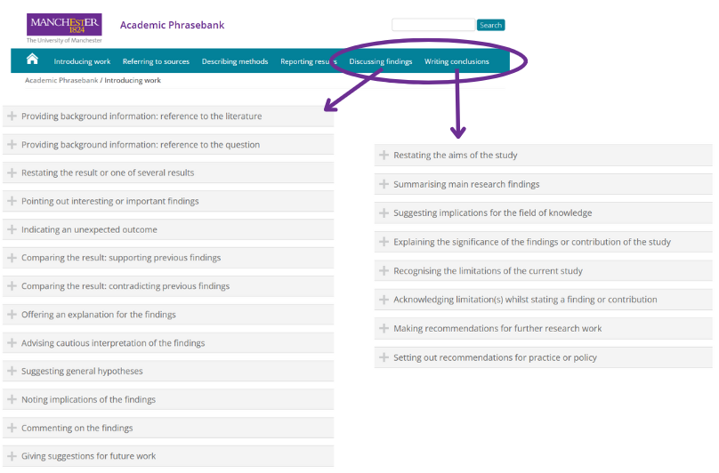

Critical Reflection - Acknowledging Limitations, Omissions, Etc.

One may question whether …
a number of reservations/limitations
One cause for concern is …
It is not necessarily the case that …
it would be more accurate to say that …
a more promising approach would be …
a more plausible explanation would be that …
… must be examined more closely
… cannot be accepted as it stands
more needs to be said about …
However, given these reservations, …
Despite these reservations, …
Despite these limitations, …
Given these qualifications, …

Other perspectives
Other possible explanations or causes are …
An alternative explanation would be …
One possible explanation for … is …
A more plausible explanation for … would be that …

Bibliography

Bibliography

Include full MLA citations for any and all:
Sources of data,
Sources for images,
Sources of background info,
Previous studies you reference,
Math reference sources used

Citation generator and guide linked here!

Appendices

Appendices
The “presentation” criterion (4 marks) assesses the organization and coherence of the exploration.
A coherent exploration is logically developed, easy to follow and meets its aim. This refers to the overall structure or framework, including introduction, body, conclusion and how well the different parts link to each other.
A well-organized exploration includes an introduction, describes the aim of the exploration and has a conclusion. Relevant graphs, tables and diagrams should accompany the work in the appropriate place and not be attached as appendices to the document. Appendices should be used to include information on large data sets, additional graphs, diagrams and tables.
A concise exploration does not show irrelevant or unnecessary repetitive calculations, graphs or descriptions.

